2025中考英语作文热点话题押题 6个!!!
热点话题作文押题一：中美贸易战
❤ 【范文】
Dear Presidentlrump
Hi！I' m always trying to call you, but l haven' t found your phone number, So l’ m writing to advise you to stop the tradewar with our country- China.

Here are some of my opinions. First, Chinese products are popular among Americans because of their excellent quality andreasonable price, Second, china has a wide variety of products to meet the needs of Americans. Third, some of China’s productsare creative. American factories can't make on their own and the products have no ateratives. Finaly, some cultural productscontains traditional culture elements. They can't be replaced by any other product.
For better and more convenient life of most Americans, l’m strongly suggesting that you should do something to stop thetrade war between China and America right now.
Yours,
Li Ming
❤ 【译文】
尊敬的总统先生
嗨！我总是想给你打电话，但我找不到你的电话号码，所以我写信建议你停止与我们国家——中国的贸易战。
以下是我的一些观点。首先，中国产品因其卓越的品质和合理的价格在美国人中很受欢迎。其次，中国有各种各样的产品来满足美国人的需求。第三，中国的一些产品很有创意。美国工厂不能自己生产，产品也没有添加剂。最后，一些文化产品包含了传统文化元素。它们不能被任何其他产品所取代。
为了让大多数美国人过上更好、更方便的生活，我强烈建议你现在就应该采取行动阻止中美之间的贸易战。
你的李明
2025中考英语作文热点话题押题 6个!!!
热点话题作文押题二：2025年春晚
❤ 【范文】
Traditional Chinese Culture at the 2025 Spring Festival Gala
As a school newspaper reporter, l was deeply impressed by the rich traditional Chinese culture at the 2025 Spring Festival Gala
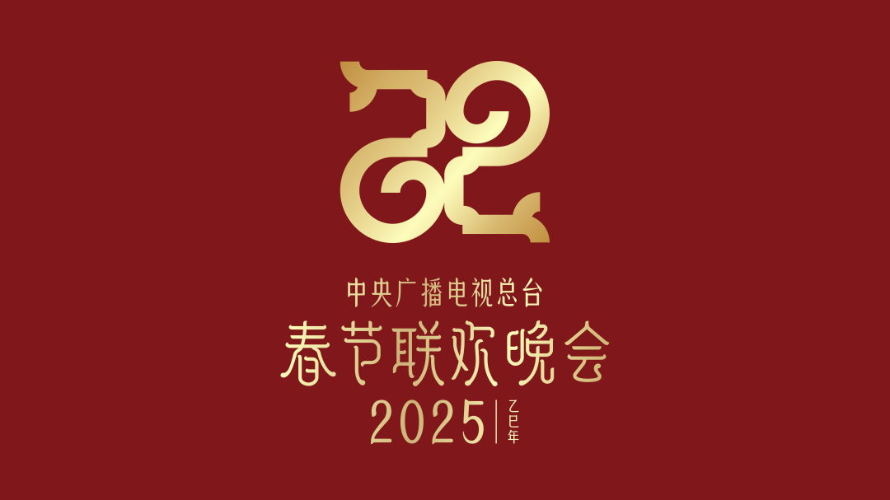
I' d like to introduce paper-cutting. lt is a kind of traditional Chinese folk art. At the Spring Festival, people usually put papercuts on windows and doors for good luck. Paper-cuts have different pretty shapes and carry people’s hopes for a good life.
Paper-cutting made the Gala more interesting and meaningful. They helped both kids and adults feel the warmth and life ofthis traditional folk art. l was amazed by the beauty of our traditional culture. lt’s our duty to protect these treasures and let theworld know about Chinese traditions.
❤ 【译文】
2025年春节联欢晚会上的中国传统文化
作为一名校报记者，我对2025年春节联欢晚会上丰富的中国传统文化印象深刻
我想介绍一下剪纸。这是一种中国传统民间艺术。在春节，人们通常在门窗上贴剪纸以祈求好运。剪纸有不同的漂亮形状，承载着人们对美好生活的希望。
剪纸使晚会更加有趣和有意义。他们帮助孩子们和成年人感受到了这种传统民间艺术的温暖和生命。我对我们传统文化的美丽感到惊讶。我们有责任保护这些珍宝，让世界了解中国的传统。
2025中考英语作文热点话题押题 6个!!!
热点话题作文押题三：DeepSeek/人工智能
❤ 【范文】
Dear Jack
I heard you are interested in Al. Let me tell you more about it.
Al is like a smart robot brain that can learn, think, and do tasks on its own. Al can solve problems, play games, and even talk topeople.
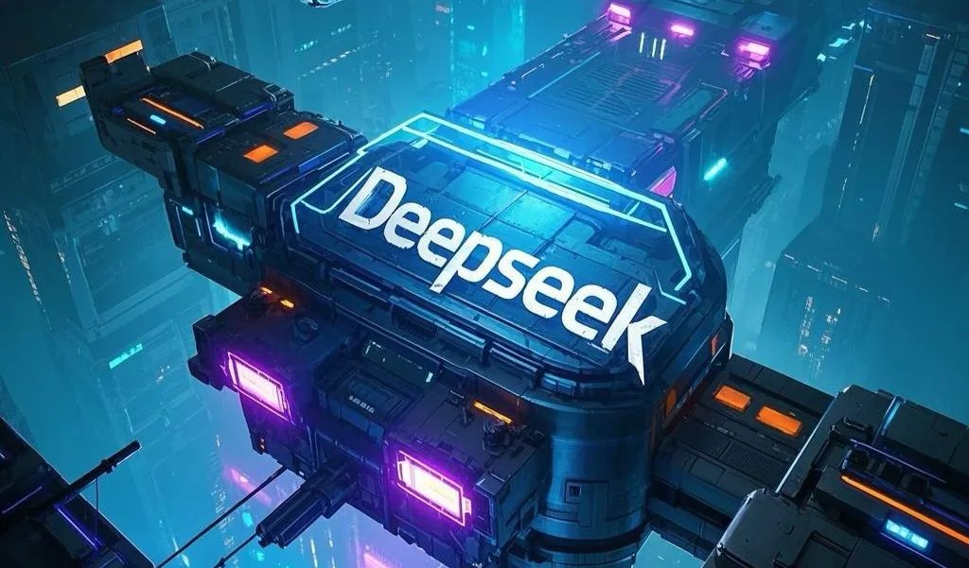
Al changes our life in many ways. We now have smartphones that understand what we say. Cars can drive themselves withoutdrivers, Doctors use Al to help find ilnesses faster, At home, we have robots to help us with household chores.
I think we should welcome Al but also be careful. We need to learn about it and make sure it is used to help people, not harmanyone. Also, we should keep learning so that we can work with Al in the future.
I'm looking forward to your reply,
Best wishes,
Li Hua
❤ 【译文】
亲爱的杰克
我听说你对艾尔感兴趣。让我告诉你更多。
Al就像一个聪明的机器人大脑，可以自己学习、思考和完成任务。艾尔可以解决问题，玩游戏，甚至和人交谈。
艾尔在很多方面改变了我们的生活。我们现在有了能理解我们说话的智能手机。汽车可以在没有司机的情况下自动驾驶，医生用人工智能来帮助更快地找到婴儿，在家里，我们有机器人来帮助我们做家务。
我认为我们应该欢迎艾尔，但也要小心。我们需要了解它，并确保它被用来帮助人们，而不是帮助任何人。此外，我们应该不断学习，以便将来能与Al合作。
我期待着你的回复，
最美好的祝福，
李华
2025中考英语作文热点话题押题 6个!!!
热点话题作文押题四：电影《哪吒之魔童闹海》
❤ 【范文】
Movies make our life more colorful. They not only bring us fun but also teach us valuable lessons. Among all the movies i' vewatched, Ne Zha 2 is my favorite.
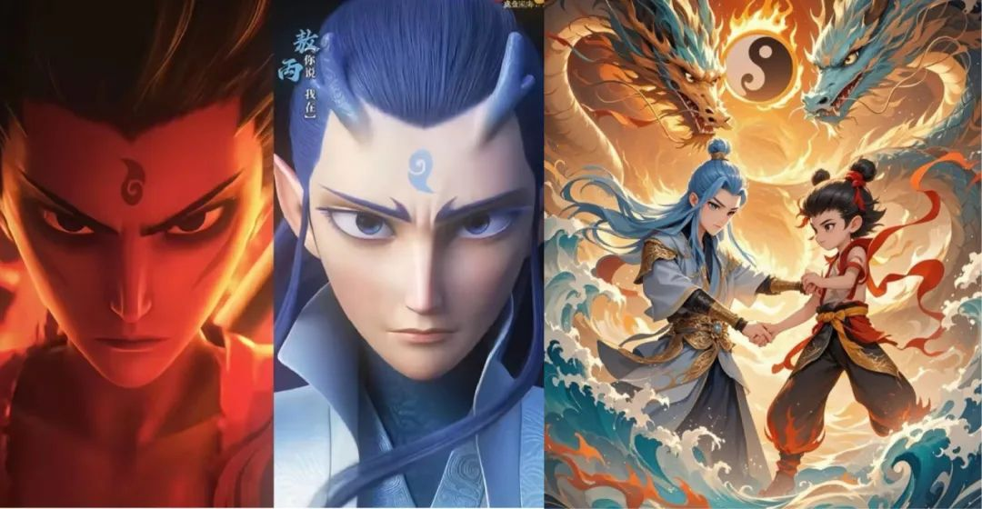
The movie follows the story of Ne Zha, a young boy with magical powers. In the movie, Ne Zha teams up with his friend, AoBing, to fight against powerful enemies while facing many challenges along the way. Here are the reasons why l like this movie.First, it has amazing action scenes that make the whole movie exciting. Second, the storyline is great, filled with unexpected twists
and moving moments, and the ending leaves me wondering what will happen next.The movie teaches me important lessons about believing in myself and fighting for what is right, t also teaches me theimportance of friendship and courage.
❤ 【译文】
电影使我们的生活更加丰富多彩。它们不仅给我们带来了乐趣，也给我们上了宝贵的一课。在我看过的所有电影中，《哪吒2》是我最喜欢的。
这部电影讲述了一个拥有神奇力量的小男孩哪吒的故事。在电影中，哪吒和他的朋友敖冰联手对抗强大的敌人，同时面临着许多挑战。以下是我喜欢这部电影的原因。首先，它有令人惊叹的动作场面，使整部电影令人兴奋。第二，故事情节很棒，充满了意想不到的曲折
感人的时刻，结局让我想知道接下来会发生什么。这部电影教会了我关于相信自己和为正义而战的重要一课，也教会了我友谊和勇气的重要性。
2025中考英语作文热点话题押题 6个!!!
热点话题作文押题五：李子柒
❤ 【范文】
Dear Chris.
l know you are interested in Chinese culture, so l' m very excited to share a wonderful event with you.
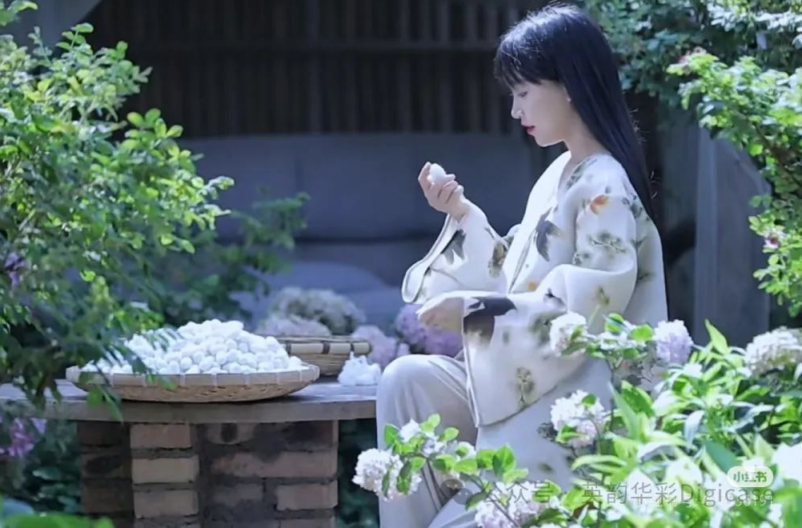
On January 28th, 2025, Li Ziqi, a famous short-video maker, showed 13 intangible cultural heritage skills on the Spring festivalGala. in the opening show, she wore a long beautiful dress. When she spread her hands, huge butterfly wings with special designsappeared, showing traditional handicrafts like paper-cutting and embroidery, which was a mix of modern technology andtraditional beauty.
This event is really meaningful and l think it is important to spread traditional Chinese culture. it not only helps the world betteiunderstand China’s long history and rich values, but also keeps these ancient skills alive.
Yours
Li Hua

❤ 【译文】
亲爱的克里斯，
我知道你对中国文化很感兴趣，所以我很高兴能和你分享一个精彩的活动。
2025年1月28日，著名短视频制作人李子柒在春晚上展示了13项非物质文化遗产技艺。在开幕式上，她穿了一件漂亮的长裙。当她张开双手时，巨大的蝴蝶翅膀上露出了特殊的图案，展示了剪纸和刺绣等传统手工艺品，这是现代技术和传统美的结合。
这次活动真的很有意义，我认为传播中国传统文化很重要。它不仅帮助世界更好地了解中国悠久的历史和丰富的价值观，而且使这些古老的技艺得以延续。
你的李华
2025中考英语作文热点话题押题 6个!!!
热点话题作文押题六：体重管理年
❤ 【范文】
My Plans of Healthy Life
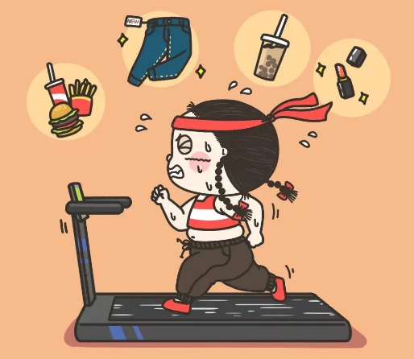
2025 is the Weight Management Year, and everyone should take action to improve their health. To live a healthy life, l havemade three main plans. firstly, l will eat more vegetables and fruits every day. Instead of junk food like chips and cola, !' llchoose milk and nuts as snacks. Secondly, l plan to exercise for 30 minutes every day. Playing basketball with classmatesafter school and riding bikes on weekends wil be my favorite activities. finally, l promise to go to bed before 10 p.m. andsleep 8 hours each night. This will help me stay energetic. By following these plans, l believe l can keep fit and set a goodexample for others.
❤ 【译文】
我的健康生活计划
2025年是体重管理年，每个人都应该采取行动改善健康状况。为了过上健康的生活，我制定了三个主要计划。首先，我会每天多吃蔬菜和水果。而不是像薯片和可乐这样的垃圾食品！我会选择牛奶和坚果作为零食。其次，我计划每天锻炼30分钟。放学后和同学打篮球，周末骑自行车将是我最喜欢的活动。最后，我保证晚上10点前上床睡觉，每晚睡8个小时。这将帮助我保持活力。通过遵循这些计划，我相信我可以保持健康，并为他人树立一个好榜样。

