2025学年七年级英语下册期末作文押题
❤（一）❤
假如你是李明，请你根据下面记录的一日活动手账图写一篇英语日记。
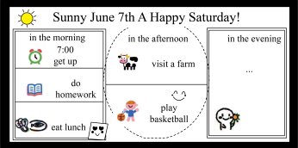

注意:（1）日记中必须包含图中所有信息，可适当拓展。
（2）日记中不得出现真实的地名、校名和人名。
（3）词数80个左右。
❤【范文】
Saturday, June 7th, Sunny
Today was a great Saturday. l got up at 7: 00 in the morning. After that, l had breakfast. Then l did my homework. it took meabout one hour to finish it, Then l ate a delicious lunch. l ate vegetables and fish.
In the afternoon, l visited a farm. l saw many cows and other animals. There l rode the horse and talked with the farmers abouttheir life. it was so interesting! Later, l played basketball with my friends. We had a lot of fun. n the evening,l helped my mum cookdinner at home. After dinner, we watched a funny movie and enjoyed a relaxing time.
What a wonderful Saturday!
2025学年七年级英语下册期末作文押题
❤（二）❤
在过去一年的初一学习和生活中，你肯定参加过一些户外活动，像学校旅行或露营等。你们班将开展以“An amazing outdoor activity”为题的英文征文活动，请根据以下要点完成一篇80词左右的文章。
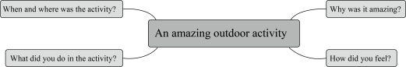

❤【范文】
An amazing outdoor activity
Time flies by quickly. In the past year, I took part in many outdoor activities.
Last autumn, our class went on a hiking trip to Green Mountain. The weather was perfect-sunny and cool. We carriedsmall backpacks with water and snacks. During the hike, we saw colorful leaves and heard birds singing. The best part wasreaching the top! The view was breathtaking-we could see the whole city. Our teacher took photos for us. After a picniclunch, we played games and laughed a lot.
It was tiring but unforgettable. l hope we can go again next year!
2025学年七年级英语下册期末作文押题
❤（三）❤
在你校将在英语周举办题为“An unforgettable school trip”的英语征文比赛。请你根据以下思维导图的内容提示写一篇短文。词数80左右。
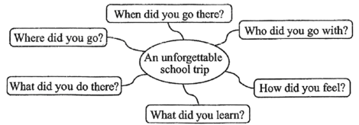

❤【范文】
An unforgettable school trip
Our school organized a trip to the Science Museum last Saturday. l went there with all the students and teachers of Grade 9together.
We got together at 8:00 a.m. at the school gate and left for the museum by bus. We took a lecture by the guide as soon as wegot there. After that,we took a visit around the diferent halls of the museum. A variety of advanced inventions had been displavedfrom the appliance to industry, education and life. What impressed me most was the experience of the usage of them, which mademe have a better understanding of the knowledge of Al, We also enjoyed the delicious food cooked by an Al robot. How amazing!
At the end of the visit, we said goodbye to the Al quide. lt is a meaningful trip which not only broadens our horizon of thecreation world, but also builds up our national confidence. l made up my mind to study hard and make a contribution to mymotherland.
2025学年七年级英语下册期末作文押题
❤（四）❤
亲爱的同学们，你和你的家长或朋友一定去过某个地方旅游。假如你是李华，请你根据下面的要点提示，给你的好朋友Peter写一封邮件，分享你的某次旅行的经历。
要点提示：1. When and where did you go?2. Who did you go with?3. What did you do?4. How did you feel about the trip?
注意：1.邮件必须包含内容要点，可适当发挥。2.邮件中不得出现真实的人名和校名。3.字数80词左右，邮件的开头和结尾已经给出，不计入总词数。
❤【范文】
Dear Peter,
How’s it going?l’d love to share my wonderful trip to Sanya with you.
Last summer, l went there with my parents. We enjoyed the golden beaches and clear blue sea. l tried surfing for thefirst time, which was exciting! We also visited a tropical forest and tasted delicious seafood.
The trip was unforgettable because it was both relaxing and fun. l felt so happy and refreshed. Have you ever been toSanya? l highly recommend it!
Looking forward to your reply.
Yours,
Li Hua
2025学年七年级英语下册期末作文押题
❤（五）❤
孔子教导我们“言必行，行必果”。诚信，是刻在中华民族血脉里的精神基因，是跨越千年时空的文明传承。在我们的生活中，诚信同样闪烁着耀眼的光芒—或许是考试时抵制诱惑的坚守，或许是犯错后主动承认错误的勇气，又或许是拾金不昧彰显美德。
请你以“An Experience of Being Honest”为题，根据以上信息，写一篇不少于60个单词的短文。回顾发生在你身上的一次有关诚信的经历，并谈谈你从这次经历中明白了什么道理。
❤【范文】
An experience of Being Honest
Last month, l found a wallet in the school playground. lt was full of money and had a student card inside. l didn’t hesitate andgave it to our teacher. ater, the owner was very thankful. from this experience, l understood that being honest brings trust andrespect. Honesty is not only a virtue but also a light that guides our lives.

