2025新人教版八上英语Unit1-8单元话题范文
Unit 1 Happy Holiday
每个人的假期都是丰富多彩的，今年你一定度过了一个特别且精彩的暑假。请以“A special trip”为题，写一篇英语作文。
提示：
1. 字数不得少于80字。
2. 重点阐述special。
3. 文中不得出现真实的人名。
❤ 【范文】
A special trip
I had a meaningful summer vacation this year. My parents took me back to the countryside where my grandparents lived. Mygrandparents had a small garden where they grew a lot of vegetables and fruits. My parents and l helped our grandparents takecare of the garden and do farm work. lt was healthy that to eat the vegetables for us. At the same time, there was fresh air and nocrowded traffic.The people living here lived very comfortably.
All in all, l really liked it and had a good time here. l hope to come again next summer vacation.
2025新人教版八上英语Unit1-8单元话题范文
Unit 2 Home Sweet Home
帮助做家务不仅培养孩子们的独立性、拥有必要的生活技能，而且很容易帮助孩子们获得强烈的满足感，增强家庭责任感，同时增进了与父母的情感交流，让家成为最舒适温暖的地方。请以I helped parents with housework为题，谈谈生活中你帮助父母做家务的一次经历以及你的收获和感悟。
要求：
1. 文章条理清晰，内容充实，语言流，书写工整。
2. 不允许写真实姓名和学校名。
3. 字数110词左右。
❤ 【范文】
I Helped Parents with Housework
Last weekend, l decided to help my parents with the housework. l stated by cleaning the living room, dusting the furniture andsweeping the floor, Then, i moved on to the kitchen and washed the dishes. After that,il did the laundry and hung the clothes todry.
Although l was tired after doing all these chores, l felt a great sense of satisfaction. l realized that by helping my parents, l wasnot only contributing to the family but also learning important life skills. Moreover, l noticed that my parents were very pleased andgrateful, which strengthened our emotional connection.
Through this experience, learned that helping with housework is a meaningful way to show love and responsibility towardsour family. it also makes our home a more warm and harmonious place. l wil continue to do my part in the future.
2025新人教版八上英语Unit1-8单元话题范文
Unit 3 Same or Different?
假如你是李华，你们学校将举办以“珍惜友谊（Value Our Friendship）”为主题的英语演讲比赛；请用英语写一篇演讲稿，介绍谁是你最好的朋友，你们之间的相似点（similarity）和不同点，以及应该怎样珍惜朋友。参考信息：
1. Who is your best friend?
2. What similarities or differences do you and your best friend have?
3. What should you do to value your friendship?
❤ 【范文】
Value Our Friendship
Friendship plays an important role in our life. My best friend is Tom. He is tal and outgoing. He has black eyes and black hairHe is very thin. He is really more hard-working than me. l am good at English, but he does wellin math. We like playing basketbal.Both he and l like sports shows. Diferences are not important in a friendship. We can respect and learn from each other. Althoughwe have some differences, we are good friends. When we are in trouble, we care about each other. We always encourage eachother, so l cherish this friendship very much, l think he's a true friend.
2025新人教版八上英语Unit1-8单元话题范文
Unit 4 Amazing Plants and Animals
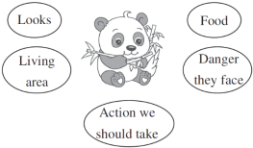
一片天真憨态奇，腹中藏竹不藏机；人言国宝殊堪贵，黑白分明有亦稀。熊猫已然成为全世界最受欢迎的动物之一。作为一名青少年，请你从以下几方面来介绍我们的国宝，并呼吁周边的人一起珍惜爱护大熊猫。80词左右。

参考词汇：自然保护区 nature reserve
❤ 【范文】
Giant pandas are the national treasure of our country.
They look very lovely with black and white fur. They are fat and have fourstrong paws. They usually live in bamboo forests and mainly feed on bamboo.
However, the cute animals are in danger now, it's dificult for pandas to have babies, and many baby pandas die when theyare very young. What'’ s worse, the bamboo forests are getting smaller now. As a result, pandas are becoming fewer and fewer.
In order to give enough food and living places to pandas, we should set up more nature reserves with lots of bamboo. Weshould give them more care in their daily life. Anyway, let’s work hard to protect pandas together.
2025新人教版八上英语Unit1-8单元话题范文
Unit 5 What a Delicious Meal!
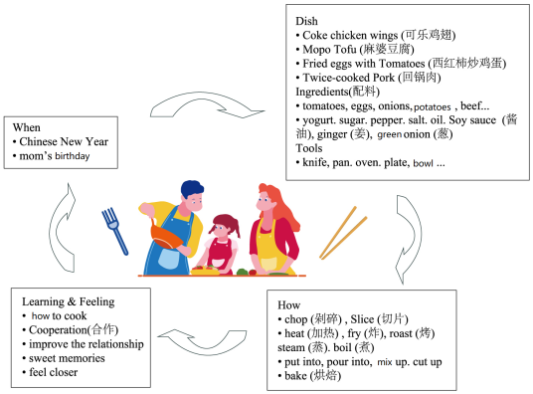
和家人一起烹饪，是温馨与爱的交融。请参考图片及文字信息，描述一次你和父母一起做饭的难忘经历，简单谈谈烹饪过程，以及你的感受或收获。

❤ 【范文】
i had an unforgettable cooking experience with my parents. l stil remember the special day clearly, which was Chinese NewYear and also my mom'’s birthday,. We decided to make a big dinner together to celebrate.
We chose dishes like Cola chicken wings, Mapo Tofu, Fried eggs with tomatoes, and Twice-cooked pork. l helped Mom withthe eggs and tomatoes, cracking and stirring eggs, before frying them with chopped tomatoes. Dad handled the other dishes,slicing beef and potatoes. The kitchen was full of laughter and delicious smells. After hours of cooking, our meal was ready. t tastedamazing!
This experience not only taught me how to make new dishes but also highlighted the value of teamwork, Cooking with myparents made us closer and created wonderful memories, i hope we can cook together more often in the future.
2025新人教版八上英语Unit1-8单元话题范文
Unit 6 Plan for Yourself
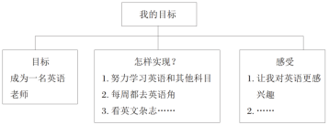
“九层之台，起于累土”，大目标的实现都是从最基本的小事开始。假设你是李华，你打算向学校英文网站投稿，分享你的目标，描述你为实现自己的目标所做的努力。请你根据以下思维导图用英语写一篇短文。

❤ 【范文】
Everyone has his goal, large or small. As for me, l want to be an English teacher when l grow up.
To achieve my goal, l wil study English and other subjects very hard at school. l will go to the English corner every Saturdaybecause l can practice my English with foreigners there. Besides, l wilread English magazines, sing English songs and watch Englishmovies when l am free
These small things make me more interested in English. And they are easy for me to do. Every time l achieve my small goal, lwill be close to my final goal. l really hope my goal will come true some day.
2025新人教版八上英语Unit1-8单元话题范文
Unit 7 When Tomorrow Comes
得科技发展日新月异，我们对未来的构想或许能够在几十年后一一实现。某青少年英语网站“Life in 2050”专栏正开展征稿活动，请你写一篇英语短文投稿。
内容包括：
1. 2050年的生活将会是怎样的？为什么？
2. 2050年的你将会是怎样的？
❤ 【范文】
Life in 2050 wil be quite different from now, Firstly, because the medicine technology keeps improving, people will live longerthan now, Secondly, there will be more robots in the world and they will help with all kinds of iobs, so people will work fewer hoursand have more free time. What's more, planes will travel faster in the future.
As a result, people will be able to take a holiday in other countries more easily.
As for me, l think !’' ll be a reporter in 2050. 1' ll visit many places and find something new, Then i will share them on theInternet so that everyone can know about them.
believe life in 2050 will be more interesting than now.
2025新人教版八上英语Unit1-8单元话题范文
Unit 8 Let's Communicate!
交流像一把钥匙，打开通往彼此内心的大门；交流也像一条纽带，让彼此的心走得更近。请说出你的故事，分享你的交流经验。
要点提示：
1. 分享你与父母、老师或朋友交流的故事。
2. 提出你关于交流的经验和技巧。
要求：
1. 80-120词。开头已给出，不计入总词数。
2. 文中不能出现自己的姓名和所在学校的名称。
❤ 【范文】
Proper communication can always improve our relations with others.
Last year, i had a misunderstanding with my bestfriend, but through open and honest communication, we were able to resolve it. We sat down and talked about ourfeelings, and l realized that l had misunderstood her intentions. This experience taught me the importance of listeningactively and expressing oneself clearly, l believe that these are the keys to effective communication. By doing so, we canbuild stronger relationships and avoid unnecessary conflicts.

