2025-2026学年（小升初）英语初一分班考培优测试卷
学校： 班级： 姓名： 学号： .
一、找出画线部分读音不同的单词，并把标号填入题前括号内。（10分）
（ B ） 1. A. banana B. cap C. glass D. father
（ D ）2. A. happy B. any C. hurry D. yellow
（ D ）3. A. much B. bus C. mug D. ruler
（ C ）4. A. seat B. see C. the D. evening
（ B ） 5. A. pen B. great C. desk D. leg

二、单词与短语。（10分）
1.写出下列词语的适当形式。（5分）
（1）long （反义词）：short
（2）hare（同音词）：hair
（3）white （反义词）：black
（4）they are （缩略形式）：they’re
（5）fat （反义词）：thin
2.英汉互译，将答案写在横线上。（5分）
（1）Sit down, please. ：请坐下
（2）a red flag：一面红旗
（3）How are you? ：你好吗？
（4）一只蓝色的鸟：a blue bird
（5）请打开窗户：Open the window, please.

三、句型。（10分）
1.用所给动词的适当形式填空。（5分）
（1） My name is（be）Li Dong. I am（be）twelve.
（2） Are（be） you her friend?
（3） Peter and Jack are （be） classmates.
（4） There are （be） many goats on the grassland.
2.单项选择。（5分）
（ C ） （1） Five and seven ________ twelve.
A. be B. are C. is D. am
（ D ）（2） -- ______ is your toy car?-- It’s on the desk.
A. Who B. What C. How D. Where
（ B ）（3） -- ______, please?-- It’s eight o’clock.
A. What’s this B. What is the time
C. What’s your name D. What about it
（ D ）（4） Mike is not at _______ school.
A. a B. an C. the D. /
（ B ）（5） – What’s six _____ three?-- It’s nine.
A. but B. and C. or D. for

四、用直线连接下列英文字母和对应的中文意思。（10分）
fridge 停放 dangerous 吸烟
medicine 楼上 smoke 吐，吐痰
upstairs 冰箱 spit 访问者
park 药 visitor 中心
touch 触摸 centre 危险的

fridge——冰箱
medicine——药
upstairs——楼上
park——停放
touch——触摸
dangerous——危险的
smoke——吸烟
summer——夏天
visitor——访问者
centre——中心

五、连词造句。（10分）
1. the, have, take, good, a, medicine, and, rest（.）
Take the medicine and have a good rest.
2. to, Zhongshan Park, get, I, can, how（?）
How can I get to Zhongshan Park?
3. help, me, my, could, lesson, you, with（?）
Could you help me with my lessons?
4. yesterday, where, they, did, go（?）
Where did they go yesterday?
5. came, at, to, we, last, school, night, nine（.）（A）
We came to school at nine last night.

六、阅读下面短文，选出最佳选项，将其序号填入提前括号内。（10分）
（A）
Mary is a good girl. She comes from the USA. She studies hard at school. Her father has a clothes shop near her home. The clothes in his shop are good and not expensive (昂贵的). People like to buy clothes in his shop. There are many people in the shop. Her father is busy.
During the summer holiday, she often helps her father in the shop. Today she does her homework. Then she walks to the shop. She helps her father to sell clothes. A boy comes to Mary. She asks politely (礼貌地), “May I help you?” The boy says, “Yes, I need a shirt.” Mary shows a green one to him, but he doesn’t like the color. His favorite color is white. Mary shows him a white shirt. The boy likes it and takes it. It’s 9:00 in the evening, and the shop closes. Mary sells many clothes. She is tired, but she feels happy.
（ D ）1. Mary __________ and she studies hard at school.
A．is from England B．lives in China now
C．lives far from school D．is a good student
（ B ）2. Her father __________ and he is busy every day.
A．is a teacher B．sells clothes C．sells food D．makes clothes
（ C ）3. Why are there so many people in her father’s shop?
A．Because the shop is new.
B．Because the clothes are fashionable.
C．Because the clothes are good and cheap.
D．Because her father is friendly to everyone.
（ A ）4. What does Mary help her father to do during the summer holiday?
A．To sell clothes. B．To wash clothes.
C．To make clothes. D．To clean the shop.
（ C ）5. What does the boy want to buy in the shop?
A．A green coat. B．A green shirt. C．A white shirt. D．A white coat.
（B）
Hi, boys and girls! Good to see you. I’m Liu Qiang. I’m forty-five years old. I’m from China. And I’m the manager of a hotel. I work very hard. My telephone number is 85226097. This is a photo of my family. The woman on my left is my wife (妻子), Amy. She is from France (法国). She is forty years old. She is an actor. She is kind. Her telephone number is 85229035. I have a daughter and a son. My son is Liu Kai. He is nine years old. He is next to my wife in the photo. Who is the girl in front of me? She is my daughter. Her name is Liu Na. And she is five. What about the woman and the man behind me? Those are my sister, Emily and her husband, Robot. They are workers at the same shop. Their telephone number is 86350914. They have a son. He is between (在……之间) them in the photo. His name is Dick. He is only two years old. He’s a lovely baby. Do you like my family?
（ A ）1. What's Amy’s telephone number?
A．85229035. B．86350914. C．85226097. D．86359271.
（ C ）2. Where is Liu Na in the photo?
A．Behind her mother. B．Next to her uncle.
C．In front of her father. D．On the left of her aunt.
（ C ）3. Who is Dick’s mother?
A．Liu Kai. B．Amy. C．Emily. D．Robot.
（ B ）4. How many women are there in the photo?
A．Four. B．Two. C．Three. D．Five.
（ D ）5. What’s the best title (题目) of the passage?
A．My classmate. B．My friend. C．My teacher. D．My family.

七、填词（5分）
根据句意，填入所缺单词，使句子完整，每空只填一词。
1. The girl in red jumps farther (far) than I in the long jump.
2. Mike came first in the running (run) race.
3. The little boys are making (make) a model ship in the classroom now.
4. Ben sometimes studies (study) how to fly kites on Sundays.
5. Read the new words five times (time) after me.
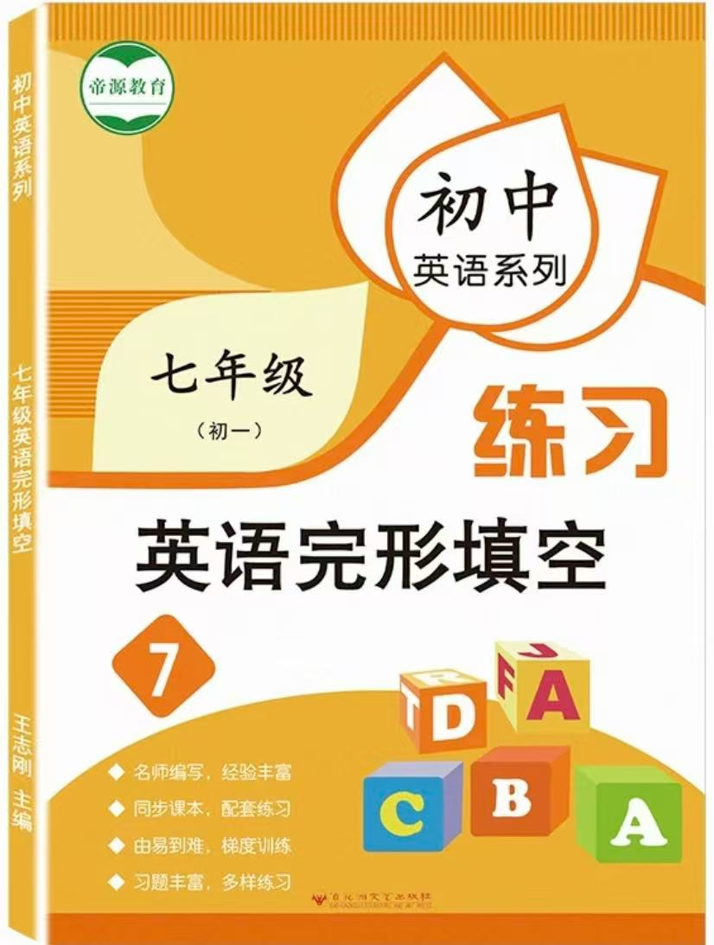
视频同款学习资料
想要的家长看主页橱窗
选中小学教辅图书
全网搜“帝源教育”

八、完形填空。（共10小题；每小题2分，满分20分）
Peter: Hello._________you in my class?
Lucy: Yes, I am. I’m Lucy.
Peter: Hi, Lucy._________name is Peter.
Lucy: Nice to meet you!
Peter: Nice to meet you, too.
Lucy: Peter, do you know the girl_________red?
Peter: That’s my_________Grace.
Lucy: Grace, a good name. What_________does she like?
Peter: Red. How about_________?
Lucy: I like_________, too. Can you introduce（介绍）me to Grace? I think we can be good_________.
Peter: OK. Grace, this_________Lucy.
Grace: Hi, Lucy. I__________Grace. Nice to meet you.
Lucy: Hi, nice to meet you. Are you in Class 3, too?
Grace: Yes. We are in the same class.
（ A ）1.A．Are B．Do C．Is D．Am
（ B ）2.A．Your B．My C．His D．Her
（ A ）3.A．in B．on C．at D．with
（ A ）4.A．sister B．mother C．teacher D．brother
（ C ）5.A．class B．sports C．color D．TV program
（ A ）6.A．you B．me C．her D．him
（ D ）7.A．green B．white C．black D．red
（ B ）8.A．students B．friends C．family D．teachers
（ A ）9.A．is B．are C．am D．/
（ C ）10.A．is B．are C．am D．/
九、书面表达。（共15分）
请以“My best friend”为题，根据下列要点提示写一篇作文：
1. Daniel，13岁，阳光中学七年级一班。
2. 戴着眼镜，个子不高。今天他穿了一件白色的T恤和一条蓝色的牛仔裤，看起来很干净。
3. 经常做运动，很少吃汉堡和喝可乐。
4. 对画画很感兴趣。没有很多时间玩电脑游戏。
5. 他家附近有一个购物中心，他经常周末在那里购物。他认为那是一个购物的好地方。
6. 最喜欢春节，家人团聚，享用美食，非常幸福。
注意：1. 词数100词左右。2. 短文须包括所有要点内容，不要逐词翻译，可适当发挥，使短文连贯通顺。
My best friend
My best friend is Daniel. He is 13 years old. He studies in Sunshine Middle School. He is in Class 1, Grade 7. He is short andwears glasses. He is wearing a white T-shirt and a pair of blue jeans today. He looks smart. He has a heathy lifestyle. He oftenexercises and he seldom has hamburgers and coke. He thinks they are bad for his health. He is interested in drawing. And he likesplaying computer games, too. As a student, he is busy with his study, so he doesn’t have much time to play computer gamesThere is a shopping mall near his home. He often goes shopping there. And he thinks it’s a good place to buy things. The SpringFestival is his favourite. Family members get together and they have a big dinner. They have lots of fun on that day.
2025-2026学年（小升初）英语初一分班考培优测试卷
学校： 班级： 姓名： 学号： .
一、找出画线部分读音不同的单词，并把标号填入题前括号内。（10分）
（ B ） 1. A. banana B. cap C. glass D. father
（ D ）2. A. happy B. any C. hurry D. yellow
（ D ）3. A. much B. bus C. mug D. ruler
（ C ）4. A. seat B. see C. the D. evening
（ B ） 5. A. pen B. great C. desk D. leg

二、单词与短语。（10分）
1.写出下列词语的适当形式。（5分）
（1）long （反义词）：short
（2）hare（同音词）：hair
（3）white （反义词）：black
（4）they are （缩略形式）：they’re
（5）fat （反义词）：thin
2.英汉互译，将答案写在横线上。（5分）
（1）Sit down, please. ：请坐下
（2）a red flag：一面红旗
（3）How are you? ：你好吗？
（4）一只蓝色的鸟：a blue bird
（5）请打开窗户：Open the window, please.

三、句型。（10分）
1.用所给动词的适当形式填空。（5分）
（1） My name is（be）Li Dong. I am（be）twelve.
（2） Are（be） you her friend?
（3） Peter and Jack are （be） classmates.
（4） There are （be） many goats on the grassland.
2.单项选择。（5分）
（ C ） （1） Five and seven ________ twelve.
A. be B. are C. is D. am
（ D ）（2） -- ______ is your toy car?-- It’s on the desk.
A. Who B. What C. How D. Where
（ B ）（3） -- ______, please?-- It’s eight o’clock.
A. What’s this B. What is the time
C. What’s your name D. What about it
（ D ）（4） Mike is not at _______ school.
A. a B. an C. the D. /
（ B ）（5） – What’s six _____ three?-- It’s nine.
A. but B. and C. or D. for

四、用直线连接下列英文字母和对应的中文意思。（10分）
fridge 停放 dangerous 吸烟
medicine 楼上 smoke 吐，吐痰
upstairs 冰箱 spit 访问者
park 药 visitor 中心
touch 触摸 centre 危险的

fridge——冰箱
medicine——药
upstairs——楼上
park——停放
touch——触摸
dangerous——危险的
smoke——吸烟
summer——夏天
visitor——访问者
centre——中心

五、连词造句。（10分）
1. the, have, take, good, a, medicine, and, rest（.）
Take the medicine and have a good rest.
2. to, Zhongshan Park, get, I, can, how（?）
How can I get to Zhongshan Park?
3. help, me, my, could, lesson, you, with（?）
Could you help me with my lessons?
4. yesterday, where, they, did, go（?）
Where did they go yesterday?
5. came, at, to, we, last, school, night, nine（.）（A）
We came to school at nine last night.

六、阅读下面短文，选出最佳选项，将其序号填入提前括号内。（10分）
（A）
Mary is a good girl. She comes from the USA. She studies hard at school. Her father has a clothes shop near her home. The clothes in his shop are good and not expensive (昂贵的). People like to buy clothes in his shop. There are many people in the shop. Her father is busy.
During the summer holiday, she often helps her father in the shop. Today she does her homework. Then she walks to the shop. She helps her father to sell clothes. A boy comes to Mary. She asks politely (礼貌地), “May I help you?” The boy says, “Yes, I need a shirt.” Mary shows a green one to him, but he doesn’t like the color. His favorite color is white. Mary shows him a white shirt. The boy likes it and takes it. It’s 9:00 in the evening, and the shop closes. Mary sells many clothes. She is tired, but she feels happy.
（ D ）1. Mary __________ and she studies hard at school.
A．is from England B．lives in China now
C．lives far from school D．is a good student
（ B ）2. Her father __________ and he is busy every day.
A．is a teacher B．sells clothes C．sells food D．makes clothes
（ C ）3. Why are there so many people in her father’s shop?
A．Because the shop is new.
B．Because the clothes are fashionable.
C．Because the clothes are good and cheap.
D．Because her father is friendly to everyone.
（ A ）4. What does Mary help her father to do during the summer holiday?
A．To sell clothes. B．To wash clothes.
C．To make clothes. D．To clean the shop.
（ C ）5. What does the boy want to buy in the shop?
A．A green coat. B．A green shirt. C．A white shirt. D．A white coat.
（B）
Hi, boys and girls! Good to see you. I’m Liu Qiang. I’m forty-five years old. I’m from China. And I’m the manager of a hotel. I work very hard. My telephone number is 85226097. This is a photo of my family. The woman on my left is my wife (妻子), Amy. She is from France (法国). She is forty years old. She is an actor. She is kind. Her telephone number is 85229035. I have a daughter and a son. My son is Liu Kai. He is nine years old. He is next to my wife in the photo. Who is the girl in front of me? She is my daughter. Her name is Liu Na. And she is five. What about the woman and the man behind me? Those are my sister, Emily and her husband, Robot. They are workers at the same shop. Their telephone number is 86350914. They have a son. He is between (在……之间) them in the photo. His name is Dick. He is only two years old. He’s a lovely baby. Do you like my family?
（ A ）1. What's Amy’s telephone number?
A．85229035. B．86350914. C．85226097. D．86359271.
（ C ）2. Where is Liu Na in the photo?
A．Behind her mother. B．Next to her uncle.
C．In front of her father. D．On the left of her aunt.
（ C ）3. Who is Dick’s mother?
A．Liu Kai. B．Amy. C．Emily. D．Robot.
（ B ）4. How many women are there in the photo?
A．Four. B．Two. C．Three. D．Five.
（ D ）5. What’s the best title (题目) of the passage?
A．My classmate. B．My friend. C．My teacher. D．My family.

七、填词（5分）
根据句意，填入所缺单词，使句子完整，每空只填一词。
1. The girl in red jumps farther (far) than I in the long jump.
2. Mike came first in the running (run) race.
3. The little boys are making (make) a model ship in the classroom now.
4. Ben sometimes studies (study) how to fly kites on Sundays.
5. Read the new words five times (time) after me.
视频同款学习资料
想要的家长看主页橱窗
选中小学教辅图书
全网搜“帝源教育”

八、完形填空。（共10小题；每小题2分，满分20分）
Peter: Hello._________you in my class?
Lucy: Yes, I am. I’m Lucy.
Peter: Hi, Lucy._________name is Peter.
Lucy: Nice to meet you!
Peter: Nice to meet you, too.
Lucy: Peter, do you know the girl_________red?
Peter: That’s my_________Grace.
Lucy: Grace, a good name. What_________does she like?
Peter: Red. How about_________?
Lucy: I like_________, too. Can you introduce（介绍）me to Grace? I think we can be good_________.
Peter: OK. Grace, this_________Lucy.
Grace: Hi, Lucy. I__________Grace. Nice to meet you.
Lucy: Hi, nice to meet you. Are you in Class 3, too?
Grace: Yes. We are in the same class.
（ A ）1.A．Are B．Do C．Is D．Am
（ B ）2.A．Your B．My C．His D．Her
（ A ）3.A．in B．on C．at D．with
（ A ）4.A．sister B．mother C．teacher D．brother
（ C ）5.A．class B．sports C．color D．TV program
（ A ）6.A．you B．me C．her D．him
（ D ）7.A．green B．white C．black D．red
（ B ）8.A．students B．friends C．family D．teachers
（ A ）9.A．is B．are C．am D．/
（ C ）10.A．is B．are C．am D．/
九、书面表达。（共15分）
请以“My best friend”为题，根据下列要点提示写一篇作文：
1. Daniel，13岁，阳光中学七年级一班。
2. 戴着眼镜，个子不高。今天他穿了一件白色的T恤和一条蓝色的牛仔裤，看起来很干净。
3. 经常做运动，很少吃汉堡和喝可乐。
4. 对画画很感兴趣。没有很多时间玩电脑游戏。
5. 他家附近有一个购物中心，他经常周末在那里购物。他认为那是一个购物的好地方。
6. 最喜欢春节，家人团聚，享用美食，非常幸福。
注意：1. 词数100词左右。2. 短文须包括所有要点内容，不要逐词翻译，可适当发挥，使短文连贯通顺。
My best friend
My best friend is Daniel. He is 13 years old. He studies in Sunshine Middle School. He is in Class 1, Grade 7. He is short andwears glasses. He is wearing a white T-shirt and a pair of blue jeans today. He looks smart. He has a heathy lifestyle. He oftenexercises and he seldom has hamburgers and coke. He thinks they are bad for his health. He is interested in drawing. And he likesplaying computer games, too. As a student, he is busy with his study, so he doesn’t have much time to play computer gamesThere is a shopping mall near his home. He often goes shopping there. And he thinks it’s a good place to buy things. The SpringFestival is his favourite. Family members get together and they have a big dinner. They have lots of fun on that day.

